Tornado Response and Recovery
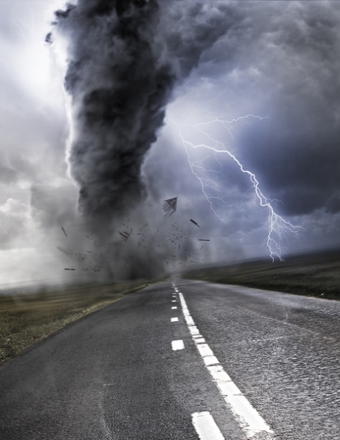
The wake of a tornado can pose numerous hazards to personnel involved in response and recovery efforts. This training provides several potential hazards you’ll find at a recovery site, as well as general safety practices.
Common hazards:
Prior to beginning work in a tornado-impacted area, assess the area to identify any potential safety or health hazards that you may encounter and plan needed controls for each.
- Hazardous conditions:
- Hazardous driving conditions
- Falling and flying objects, due to strong winds or overhanging structures
- Wet or slippery surfaces
- Unstable structures
- Electrical hazards
- Sharp objects
- Fires
- Personal hazards:
- Exhaustion from extended shifts
- Heat illness
- Dehydration
Please note: Some operations, such as utility repair or HAZMAT cleanup, can present task-specific hazards and should only be performed by properly trained and equipped individuals.
General precautions:
- Stay tuned to local radio or television for emergency and weather updates.
- Keep clear of downed power lines and any objects they may be in contact with.
- Stay aware of potential structural, chemical, or biological hazards.
- Make sure vaccinations for diseases such as hepatitis A and tetanus are current.
- Always wear appropriate clothing and PPE, including boots and gloves.
- Keep an eye out for sharp objects, e.g., loose nails, splintered materials, and broken glass.
- Keep cool and hydrated.
- Take additional precautions as needed when using generators, power tools, or any other powered or bladed objects or when using or working near heavy equipment or vehicles.
This form documents that the training specified above was presented to the listed participants. By signing below, each participant acknowledges receiving this training.

Organization:

Trainer: Trainer’s Signature:

Class Participants:

Name: Signature: Date:

Name: Signature: Date:

Name: Signature: Date:

Name: Signature: Date:

Name: Signature: Date:

Name: Signature: Date:

Name: Signature: Date:

Name: Signature: Date:

Name: Signature: Date:

Name: Signature: Date:

Name: Signature: Date:

Name: Signature: Date:

Name: Signature: Date:

Name: Signature: Date:

Name: Signature: Date:

Name: Signature: Date:

Name: Signature: Date:

Name: Signature: Date:

